**LAPORAN TUGAS MINGGU 6**

**Inheritance, Abstract Class and Interface in Java**

**Pemorgaman Berorientasi Objek**

*Resume ini disusun untuk memenuhi Tugas Mata Kuliah Pemrograman Berorientasi Objek*



Disusun oleh:

Muhammad Rivan Rivaldi 211511048

**PROGRAM STUDI D3 TEKNIK INFORMATIKA**

**JURUSAN TEKNIK KOMPUTER DAN INFORMATIKA**

**POLITEKNIK NEGERI BANDUNG**

**2021**

**Exercise 1. The Circle and Cylinder Classes**

1. Source Code Asli
2. Circle.java

1. Cylinder.java

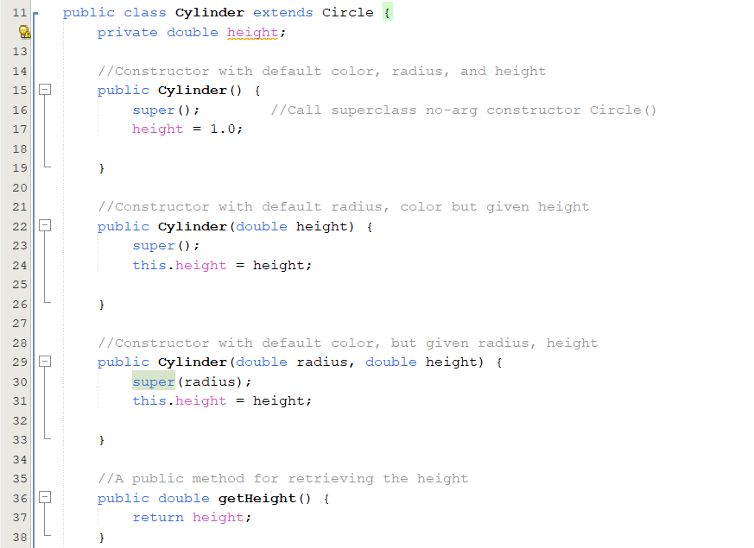

1. TestCylinder.java

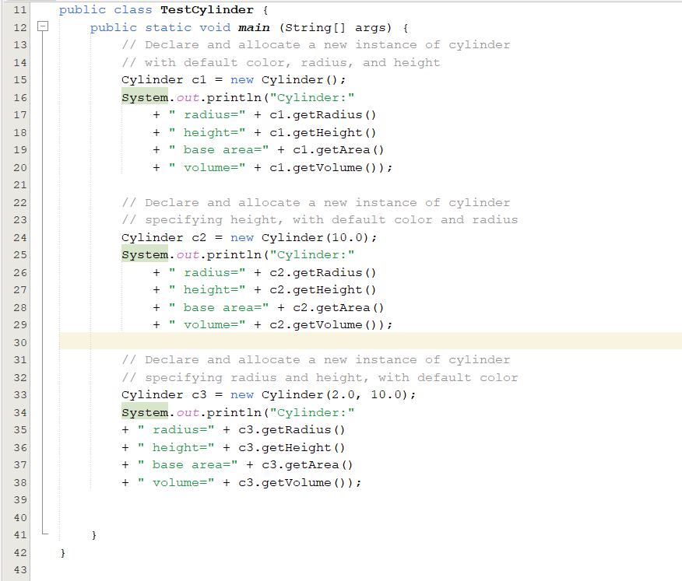

Output

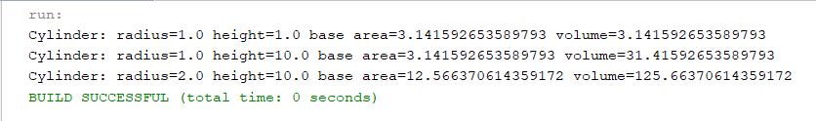

1. Source Code yang Dimanipulasi
2. Circle.java

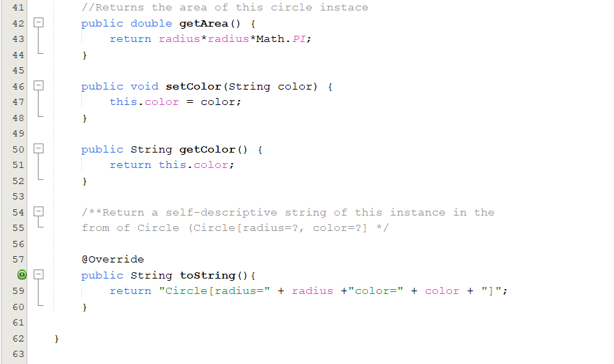

1. Cylinder.java

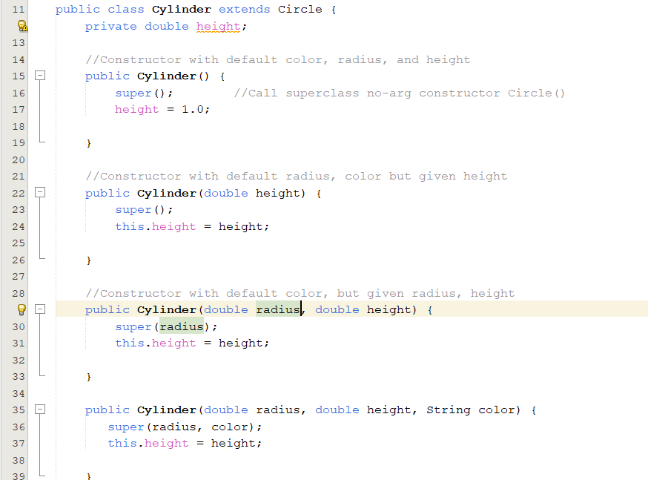

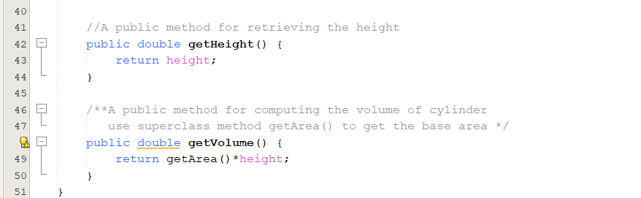

1. TestCylinder.java

Ouput

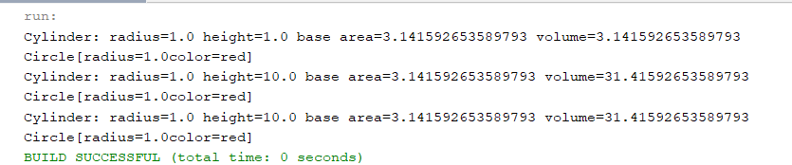

**Exercise 2. Superclass Shape and its Subclasses Circle, Rectangle and Square**

1. Shape.java

1. Circle.java

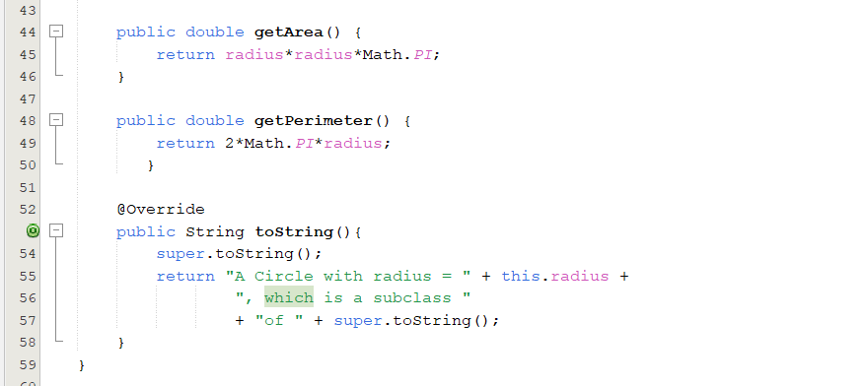

1. Rectangle.java

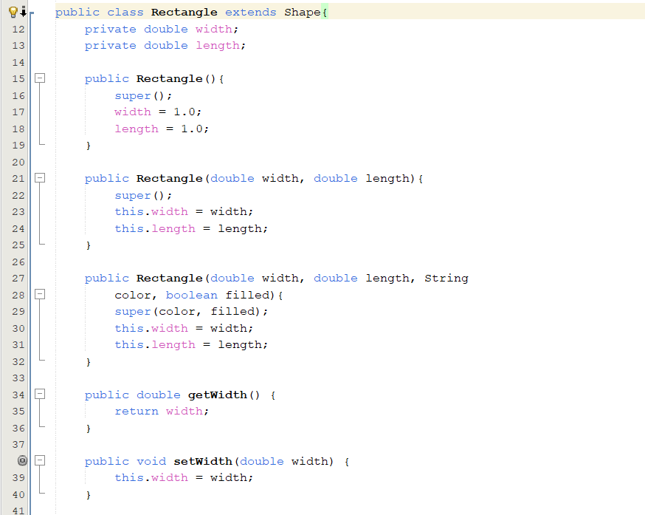

1. Square.java

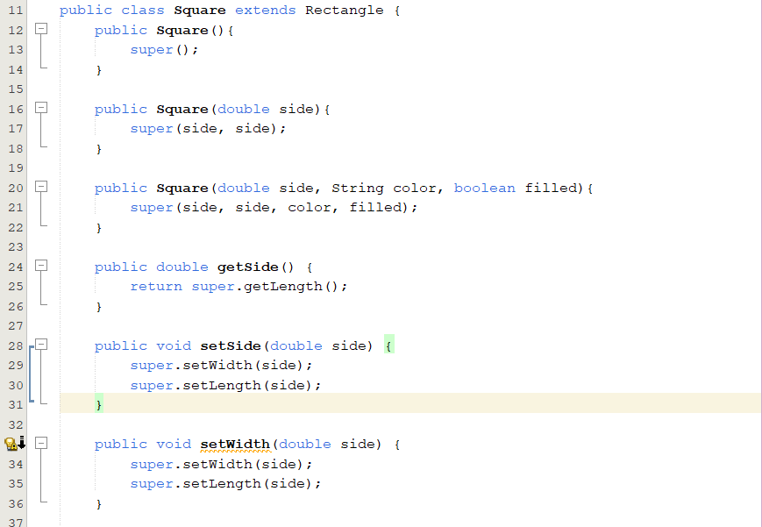

1. Main.java

Output

